Image | Details
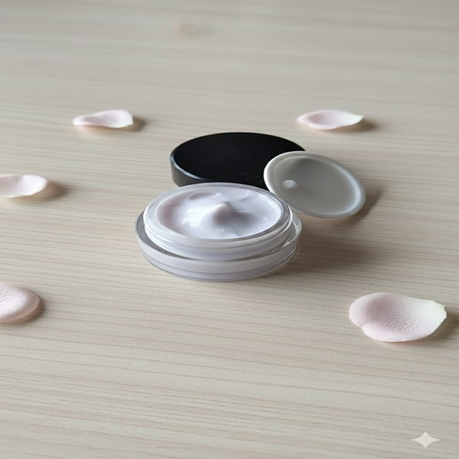 | Name:lavender creme  Prize: 150  Etc.: for dry skin
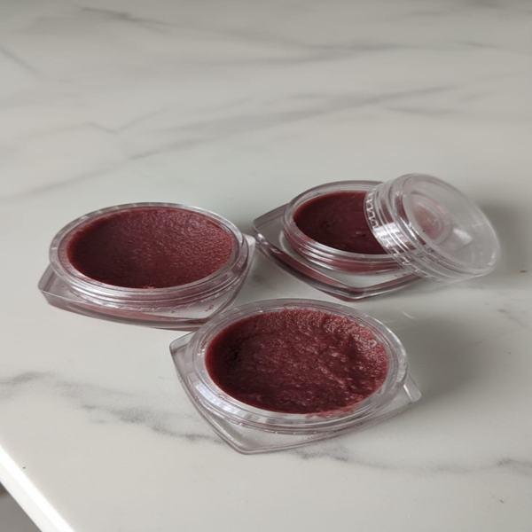 | Name: beetroot lipbalm  Prize:70  Etc.:to cure chaped and dry lips made with natural oils .. also available in alovera ,sandalwood,coffe , limegrass flavors
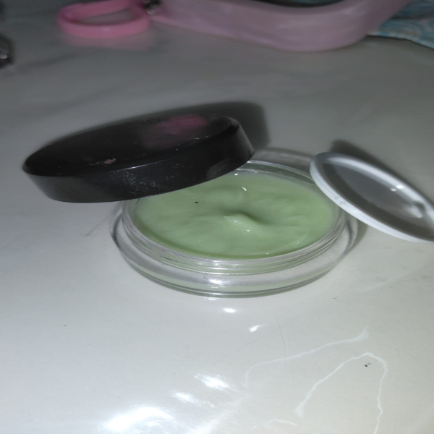 | Name:alovera aqua bass crème  Prize:120  Etc.:for oily skin
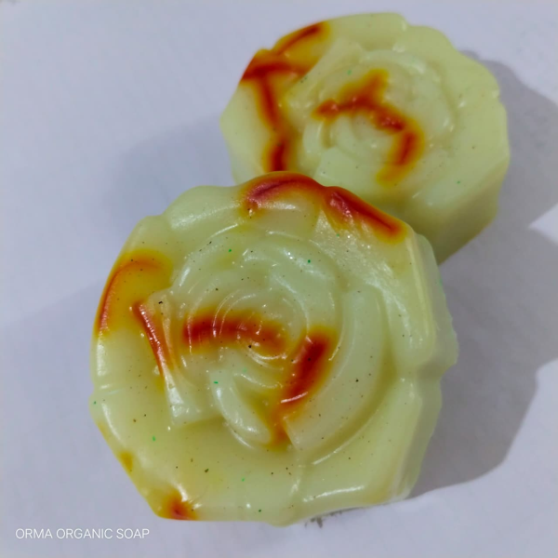 | Name:milkkesar soap  Prize:150  Etc.:for luxury bath , made with original saffron
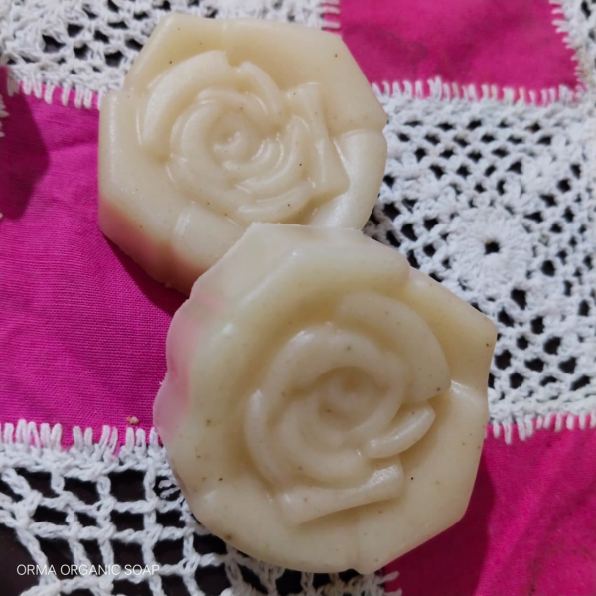 | Name:Korean rice soap  Prize:100  Etc.:for smooth and shiny Korean glass skin
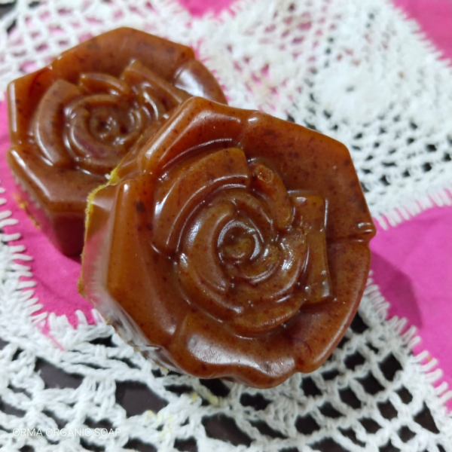 | Name:haldikesar soap  Prize: 150  Etc.:made with organic haldi and real saffron
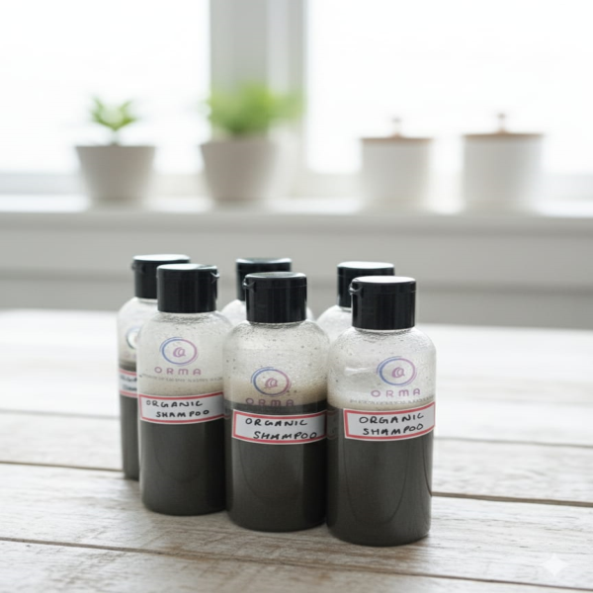 | Name:organic shampoo  Prize:100  Etc.:made with 13 auyrvedic materials
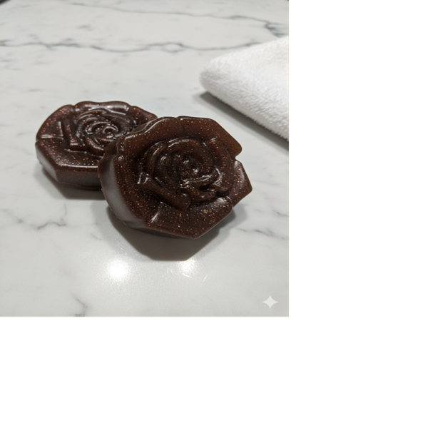 | Name:rose soap  Prize:60  Etc.:
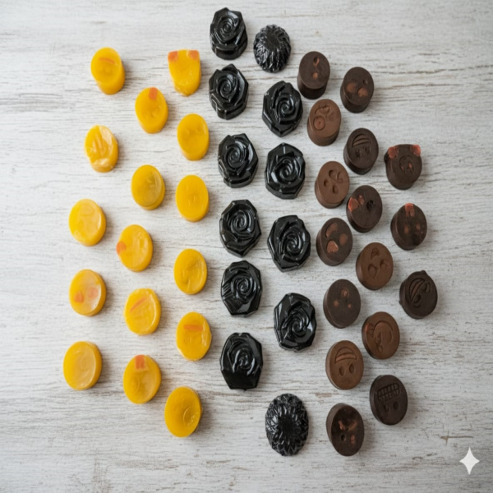 | Name:front page of soap category  Prize: all soaps depends on there measurment  Etc.:
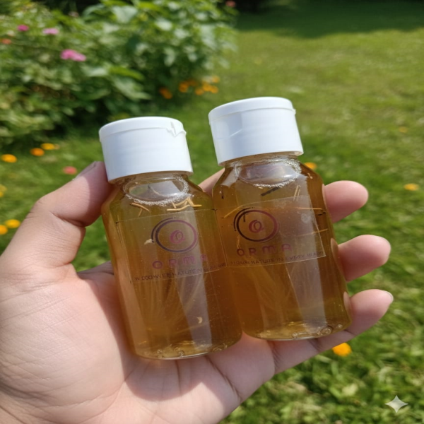 | Name:organic hair oil  Prize:120  Etc.:made with 5 aurvedic materials for shiny and strong hair
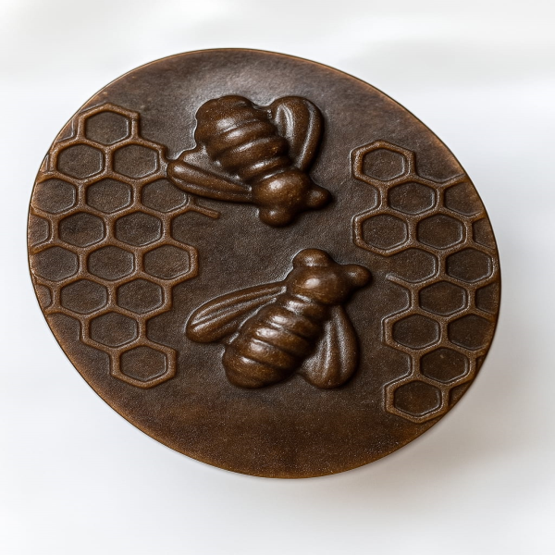 | Name:body scrub soap  Prize:70  Etc.:for exfoliation
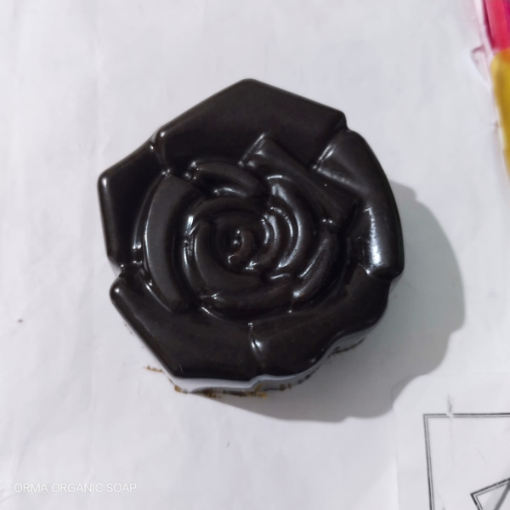 | Name:charcoal soap  Prize:70  Etc.:for tan free skin
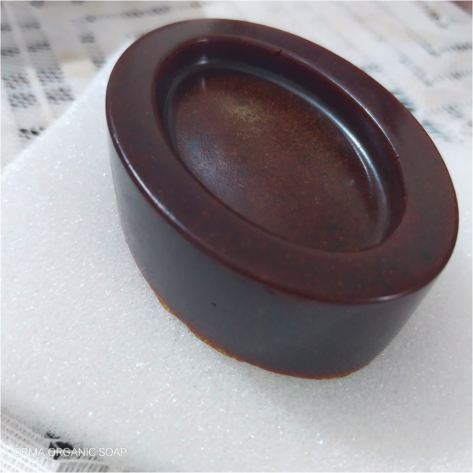 | Name:ubtan soap  Prize: 80  Etc.gives you a spa like skin:
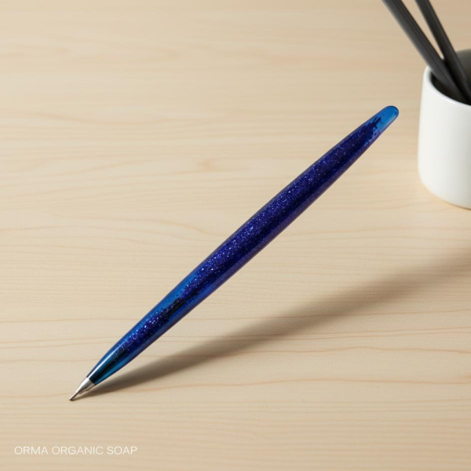 | Name; resin pen  Price: 60  Etc: perfect for gift and stylish way to write

